CONTROLLED LIMB RECOVERY
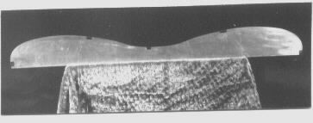
About Controlled Limb recovery Controlled limb recovery is actually built into the bow through basic design and accurate control of the influencing laminates. High speed photography combined with machine testing plays a valuable part in bringing about controlled limb recovery in my Gamemaster bows. In simple terms, this is the science of controlling the recovery of the bow limbs in such a way to give truest flight possible to the arrow. Most bow makers do not know for sure if their bow limbs recover equally. The upper limb may recover before the lower limb or visa versa, which can effect arrow flight. Actually the ideal condition for best arrow flight is if the lower limb recovers a split second before the upper, insuring the upper does not recover first, (worst condition). This amount is so slight it is hardly measurable but it does assure the best flight to the arrow under all possible conditions. No matter how bad your release, you will still have good flight with a Gamemaster.

SHELF OF SPINED GLASS
As glass can vary in spine, not only from piece to piece, but also in length, from one end to the other. Without using the highly accurate method of spining bow glass that I developed, it would be highly improbable that any bow maker could pick up this difference. This difference in spine can not be measured with a micrometer, the mic just tells the thickness, not the real strength. Bow glass has such a great influence on the bow, just a slight difference in glass strength can change shooting characteristics of a bow. The glass in a bow makes up about 80% of the bows pull weight, wood does very little in comparison, except wood plays an important part in limb stability. By spining my glass, I segregate each basic thickness into as many as 40 different individual groups. Others would be working with just 3 basic thicknesses. This variance has a great advantage (if known), by having a choice of spine, you can come up with the ideal wood and glass combinations for different bow weights and draw lengths (wood to glass ratio).
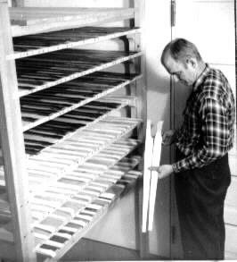

IMPORTANCE OF WOOD TO GLASS RATIO
Another important factor of accurate spining of bow glass is the wood to glass ratio. Although wood in the bow limb does very little actual work, it does play an important part in bow limb stability, mainly the flexibility of the bows limb. If the spine of the glass is not known, it would be impossible to achieve the best wood to glass ratio for a certain draw length and bow weight. There are countless different combinations of wood to glass ratios that can be used for each pound of bow weight and different draw lengths. To obtain a fast stable bow, the exact proper combinations of wood to glass should be known. I have a chart that I compute the wood to glass ratios for different weights and draw lengths. For the longer draws of over 29", I compute on a different chart. The wood to glass ratio is not based simply on the total of glass used, but the spine of the face must be computed separately and the spine of the back computed separately. A long draw should have a slightly more flexible limb. To increase limb flexibility, I decrease the wood content slightly, and increase the glass ratio slightly. By making a bow special for the longer draws, each archer will receive a bow with maximum stability suited for his draw length. When an archer purchases a bow with a no draw limit, expect a bow with a pretty flimsy limb.

The glass spine method that I developed is the most accurate method possible that can be used in bow making. It is also just as complicated as it is accurate because of the many ratios that have to be figured out. There have been many times I have spent 2 or 3 hours just figuring the best ratio for a single bow. To give you an idea of the accuracy, yet the complications, let the 4 glass laminations in a bows limb (2 upper, 2 lower) which are variable in spine, represent the last 4 digits of a phone number. By mixing the last 4 digits of phone numbers there are approximately 10,000 combinations that can be used.

Yes my method of making bows cost more and so must my bows. I have never considered time or cost in making a bow. My only consideration is how good I can make a bow, and have a bow that I can take real pride in offering to my customers. At this time there are hundreds of bow makers, 99% of experience obtained came from bow kits of one or two sources. It seems like everyone that shoots a bow, will at sometime or other become a bow maker. You will not find real custom costly made bows at any dealer; their main concern is what the mark up is, and how much money a bow will bring in.

